Assignment-14

Q.1 Write a command that puts the following values , in their given order, into the salespeople table: city- San Jose, name – Blanco, comm – Null, cnum – 1100.
Ans:

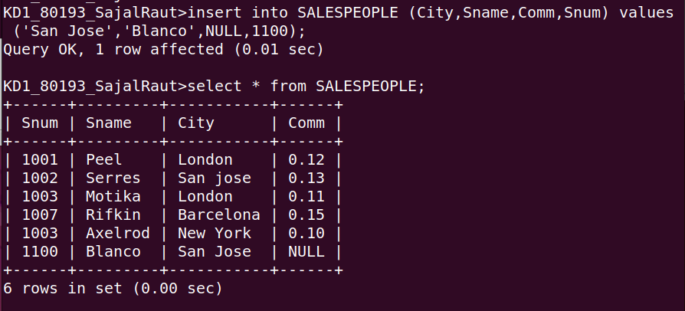
2. Write a command that removes all orders from customer clemens from the orders table.
Ans:
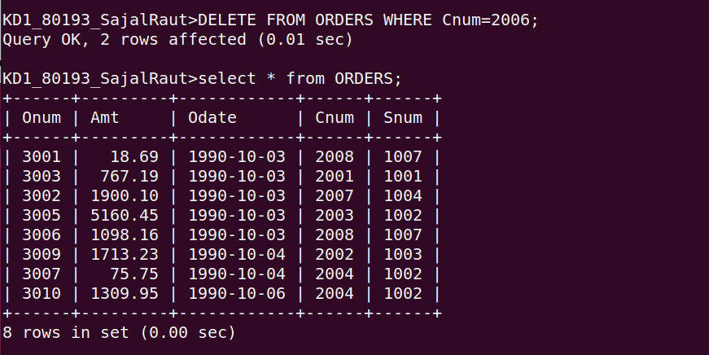

3. Write a command that increases the rating of all customers in Rome by 100.
Ans:

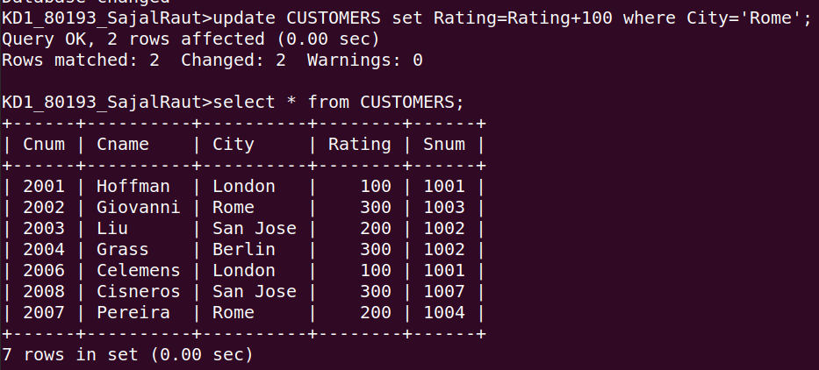
4. Salesperson serres has left the company. Assign her customers to motika.
Ans:

